Street Tree Establishment Maintenance Tips

Street trees provide many aesthetic, environmental and social benefits and have been shown to increase property values when kept in good condition. Some of the benefits of street trees are listed below.
Benefits
Street trees provide:
- Shade and cooling
- Privacy
- Visual amenity including softening, screening and enhancement of built environments
- Character
- Storm water reduction and filtration
- Improved air quality
- Habitat and food for wildlife
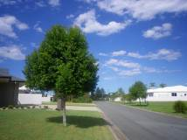Council appreciates any assistance residents are able to provide to protect and care for nature strip trees. Some general tips for keeping street trees alive and in good health are provided below.
Watering
Watering is the most important element of street tree establishment.
- Water should be applied directly to the root ball in the months following planting. This is crucial with container grown trees as their roots dry out faster than the soil around them.
- Tree roots will eventually spread into the surrounding soil, but until this happens the tree will draw water mainly from the root ball.
- Water at least twice a week in the absence of good rain, and more often in the peak of summer.
- Do not rely on automatic sprinklers or drip systems to provide the required amount of water to newly planted trees.
- Regular deep soakings are better for deep root establishment than frequent light watering’s.
- The best times to water are early in the morning or after dark. Water applied during the heat of the day is mostly lost through evaporation. The mulch surrounding street trees will help to combat some evaporative losses however it is far more efficient to water plants during cooler times.
- It is also important not to over-water new street trees. To check whether a young tree requires supplementary water, simply feel the soil layer immediately below the mulch. If the soil is dry, water can be supplied.
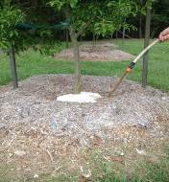
Mulching
Council mulches trees to control weeds and grasses, which compete with trees for water and nutrients. Grass will out-compete tree roots by approximately 30% when absorbing available soil moisture. You can help your nature strip tree by regularly removing grass and weeds.
Mulch also serves to conserve soil moisture, improve soil quality and protect trees from trunk injury caused by lawn mowers and whipper snippers.
Council uses organic mulch, which is the best choice for tree plantings. Should you wish to place mulch around the base of your tree it is important not to pile the material too high as this restricts the passage of air to the roots. A 10-cm layer is ideal. It is also important to maintain a small gap between the trunk of the tree and mulch layer to keep the stem base from rotting.
Grass clippings should not be used to mulch trees as they are extremely high in nitrogen content and can be toxic, especially to young establishing street trees. Grass clippings piled high around the base of a young tree are a major cause of young tree death
If you believe more mulch is needed for a street tree, please contact Council’s Customer Service Centre on 5475 7272.
Pruning
Street trees often require pruning by Council staff when young in order to develop good form.
Council also prunes street trees to:
- Remove lower branches and provide clearance over footpaths and for pedestrian and traffic for visibility;
- Remove dead/damaged limbs;
- Remove suckers that sprout from the base of the trunk; and
- Remove structural faults.
If you believe a street tree needs pruning, please contact Council’s Customer Service Centre on 5475 7272.
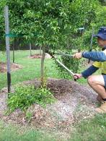

Staking
When planting new street trees, Council may stake the tree to provide initial support until new roots have formed and spread into the surrounding soil. Staking trees can also protect them from accidential equipment damage.
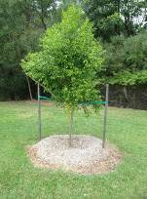Stakes should generally be removed after 12 months. If a tree is unable to support itself after this time it may hae a need to be replaced. In such cases, please contact Council on 5475 7272.

Current as at June 2017

