Earnshaw Street, Golden Beach - infiltration basin

Project summary
Council aims to improve the health of our waterways for everyone to enjoy. A new vegetated infiltration basin will be installed at a coastal outfall at Golden Beach to treat diverted stormwater from the Earnshaw Street catchment, protecting the environmental values of nearby waterways.
The vegetated infiltration basin (150m²) will be constructed in the coastal dune zone (as shown on the plan of work overleaf).
An example of a fully established, similar basin is shown below:
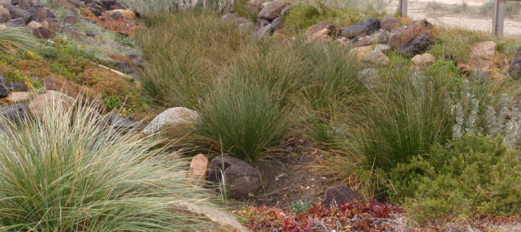
The new vegetation will consist of low lying flora similar to what is currently at the site.

Start date
Work is scheduled to start the week beginning 13 July 2015. Completion is expected within 12 weeks (weather dependant).
Beach Access and Facilities
Access to the adjacent section of beach and parking along the esplanade will be maintained during construction.
Disruption to surrounding grassed areas, play equipment, toilets and barbecue areas will be kept to a minimum where possible.
The pedestrian pathway adjacent to the project may be slightly diverted. There will be temporary fencing around work to ensure public safety.
 | A note from your local councillor  These works are an important environmental action that will be used to treat diverted stormwater before entering the Pumicestone Passage. This area is within a Marine Park and it is great for Council to deliver projects that will ensure the continued quality of the water in the Passage into the future.  I remain committed to working toward the funding and delivery of these important infrastructure projects for the benefit of our entire community.  Cr Tim Dwyer
Further information
Please contact Council’s Project Officer, Ben McGovern on the details below:
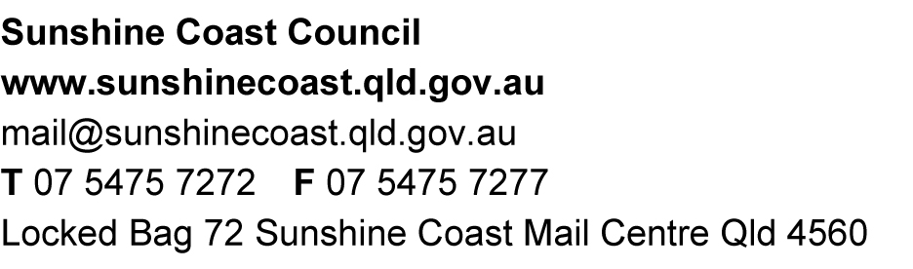

Figure 1: Location of work

