Bats in Backyards Citizen Science Project 28 – 29 Nov

Want to help end human/flying-fox conflict in urban areas?
Council’s long-term goal is to identify highly suitable low-conflict areas to encourage flying-foxes to roost in long-term.
By identifying where they are already feeding and what they are feeding on, Council can get closer to finding suitable low-conflict areas and making sure there is suitable food there to encourage flying-foxes to stay long-term.
Also, by knowing what they are feeding on, appropriate species can be planted near or in suitable long-term habitat.
What am I looking for?
At this time of year, the Sunshine Coast usually has three resident species of flying-fox—the grey headed, the black and the little red flying-fox.
Simply download the app and log any sightings of flying-foxes over the weekend.
You can record flying-fox sightings wherever you are across the Sunshine Coast. You can submit sightings from your home or go for a walk around your local area and submit as you go.
Six steps to joining the fun
- Download the “CAUL Urban Wildlife” on your Apple or android device.
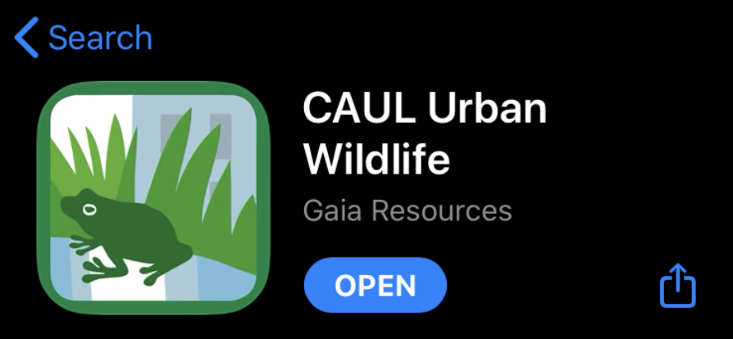

- Register your details
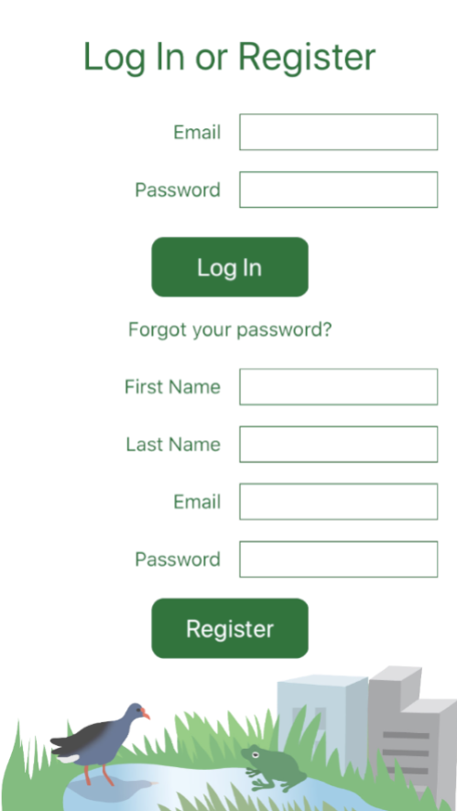

- Select the project ‘flying-foxes’

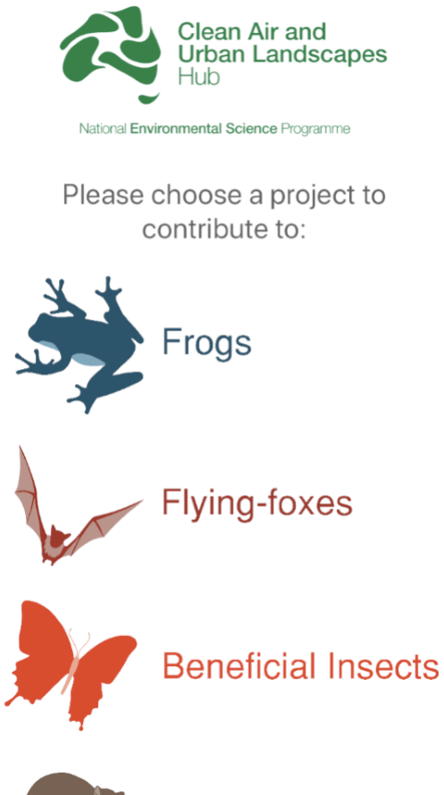

- Select ‘observe’ to submit a sighting
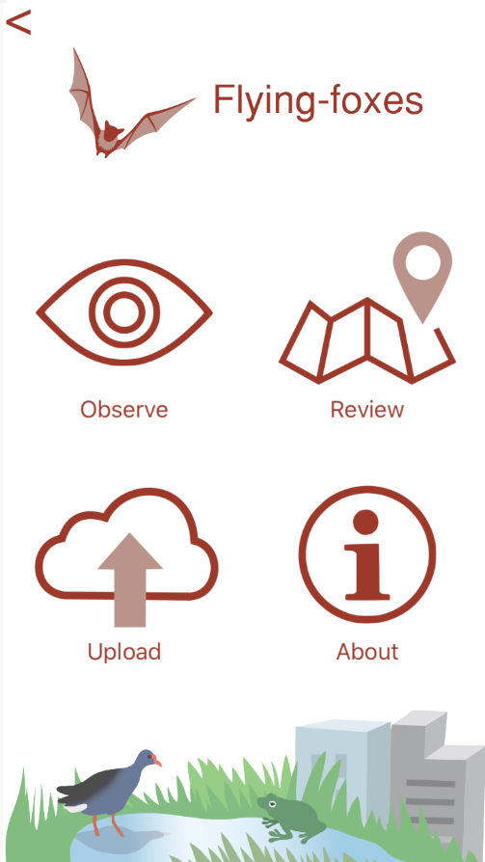

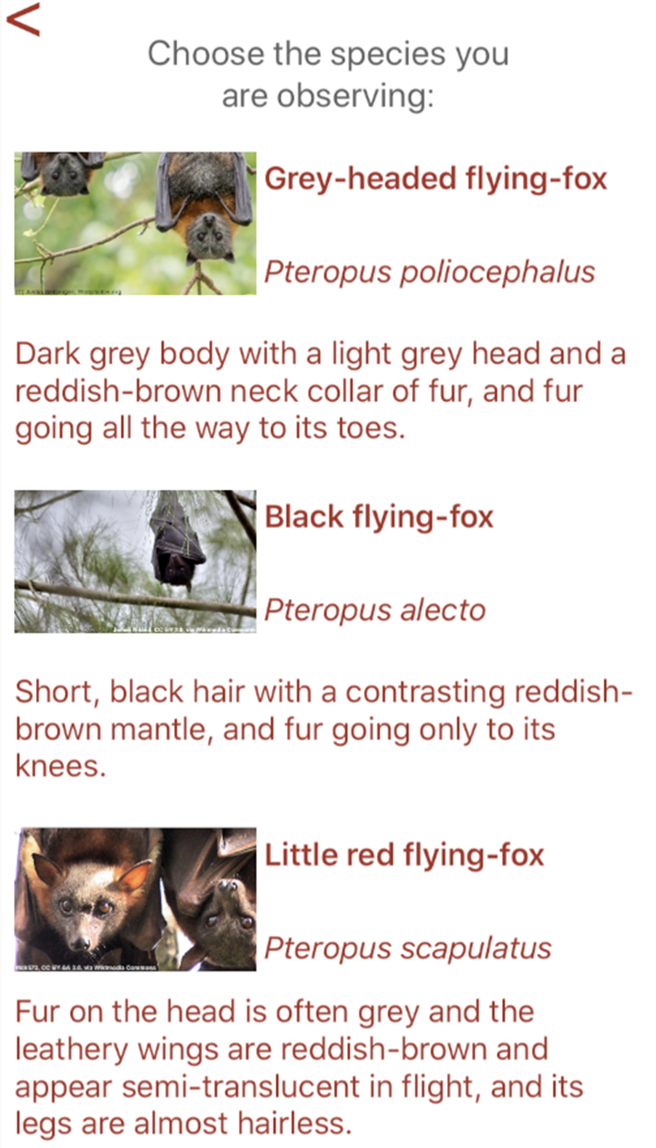
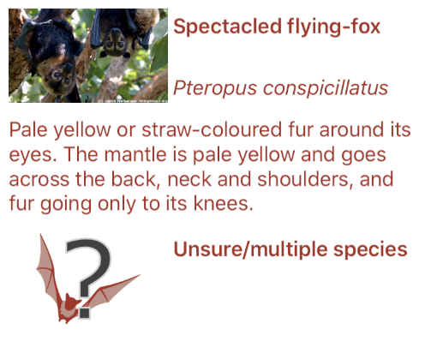
- Select the species of flying-fox you saw, or ‘unsure/multiple species’ if you are not sure which it was

- Fill in the details

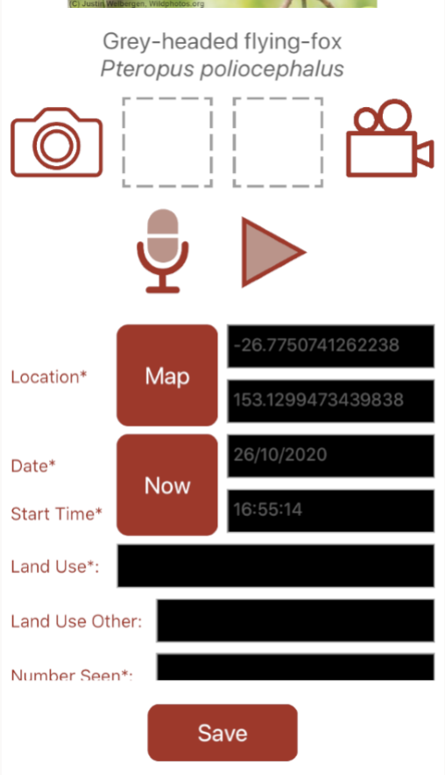
You can add a photo or recording too if you’d like. Most of the fields are drop-down boxes to select the best answer. If you want to add any other notes, you can do it in the box at the end. Then just press ‘Save’.

You can also check out all the records that have been submitted by yourself and others.

