Background - Why do we dredge?

Sunshine Coast beaches are vulnerable to erosion during storms, swells and weather events.

Approximately every two years, council replenishes the sand on Maroochydore Beach, to provide long-term protection of the foreshore and important community assets such as roads, parks and playgrounds. Our Coastline brings economic and community value to the region.

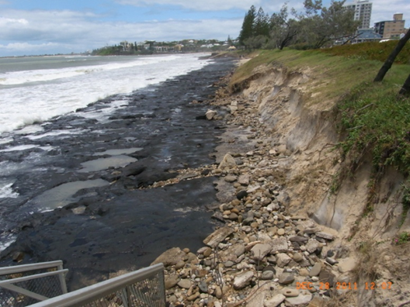

*Figure 1. 2011 summer storms left exposed coffee rock at Maroochydore Beach.*

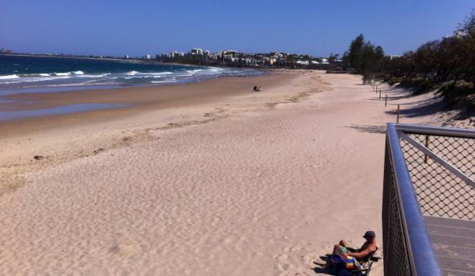

*Figure 2. Re-nourished beach – post dredging*

Dredge Safety Facts

**At the dredging site (Cotton Tree Caravan Park) you should be aware:**

* Swimming near a dredge, is like swimming through a construction site. **Swimming or using any non-powered watercraft use is not advised in this area.**
* Strong currents in rivers can pull you into the dredging area very quickly. The dredge has both floating and submerged parts. Floating buoys are used to show anchors but you can’t always see the danger below the surface!
* The dredge cutting head has sharp teeth and strong vacuum force.
* Sharp barnacles grow on the outside of the floating pipe and vessel and can cause cuts which may lead to infection. Do not interact with any dredge pipework.
* Dredge operators are working, and are focusing on their job, they can’t always be keeping an eye on you.
* Spring tides can cause faster flowing water and increase the likelihood of being pulled into a dredge area.
* Respect the exclusion zones and do not enter the delineated area on the beach.
* The dredge is sucking sand from the river system. The force of the vacuum may cause sandy banks to become unstable.

**At the deposition site (Maroochydore Beach) you should be aware:**

* The dredge sand is transported through a pipeline and deposited at the nominated beach location. The velocity of the material coming out of the pipe is extremely fast and walking through the water can cause you to lose your feet.
* The outlet dredge sand and water mixture is super saturated and can behave like quicksand.
* The sand deposited on the beach is stockpiled with an excavator and uncompacted. It can become unstable and collapse at any time.
* Always walk around the work area via the designated pedestrian walkways
* Do not enter the flagged area where machinery is working.
* Choose patrolled bathing reserves when choosing to swim.
* Throughout dredging operations, pipes are dragged along the beach with the use of excavators. Avoid machinery and pipes while this operation is being undertaken.

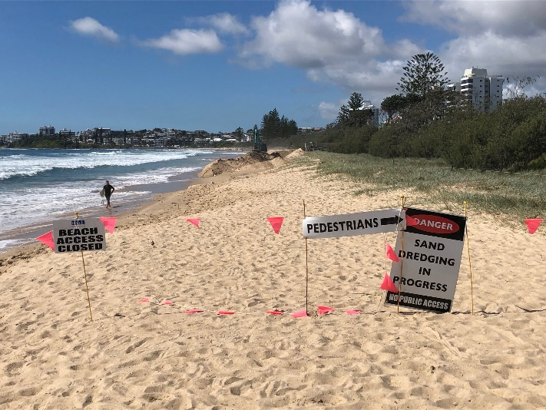

*Fig 3. Pedestrian detour signage on beach.*

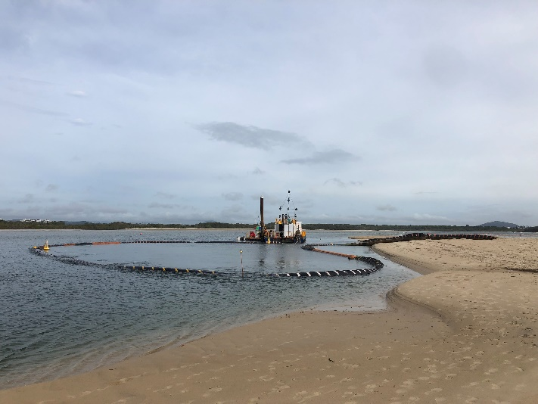

*Fig 4. Dredge vessel with floating pipeline*

Multiple work fronts:

Dredging operations require multiple work fronts.

The dredge vessel, which is located in the river, is sucking sand to be transported to the beach via a pipeline.

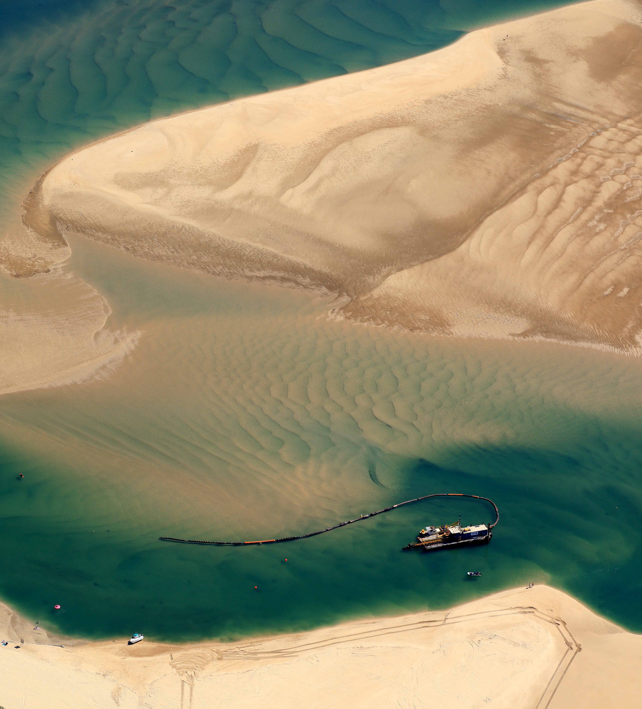

*Fig. 5 Dredge Vessel in Maroochy River shows extent of floating and submerged parts.*

The booster pumps will assist to push sand up the entire length of the beach. These pumps are mobilised with a large truck and loaded/unloaded with a crane. This area should be avoided during these operations.

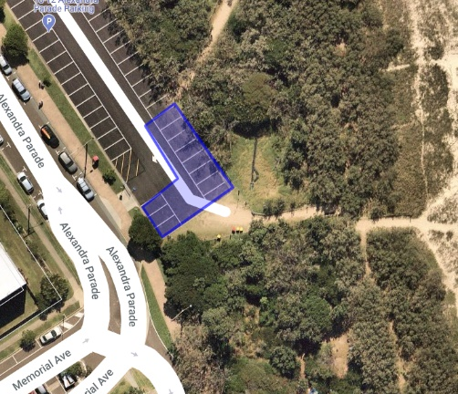 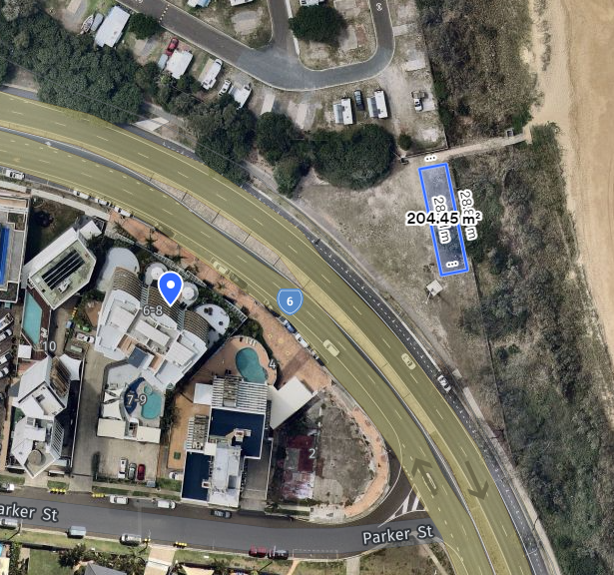

*Figure 6. Booster pump locations at Cotton Tree beach car park and Aerodrome Rd*

**On the beach:** the outlet pipe deposits sand on the beach. Operators on the beach use an excavator to create a sand bund and channel on the beach, which helps direct water the sea, while depositing sand and minimising erosion.

The sand bund requires continuous maintenance with the use of an excavator and this area should be avoided at all times.

Due to the velocity of water from the outlet pipe, the sand banks and sand bunds can become unstable at any time.

Pedestrian signage and detours are set up to assist pedestrians in avoiding danger, where required.

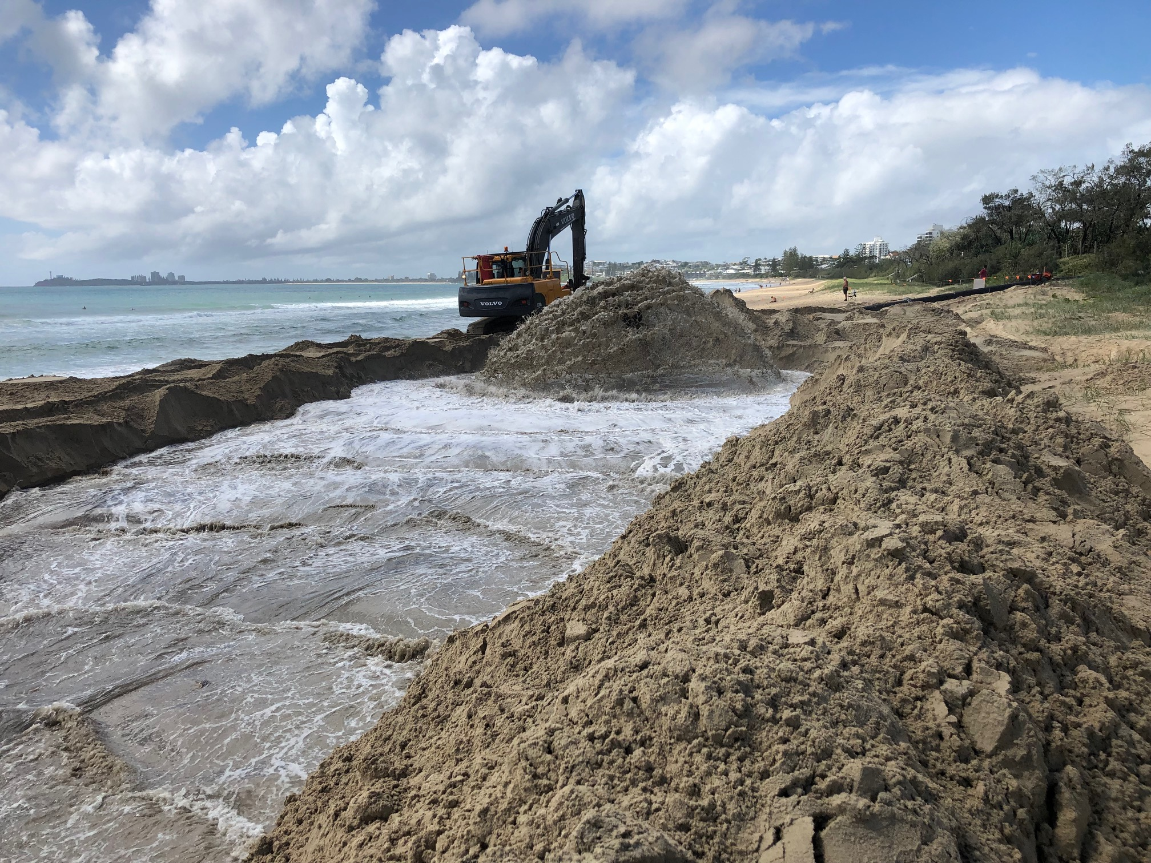

*Fig 7. Outlet pipe and channel*

Access to some parts of the following areas will be restricted to ensure community safety:

* The car park at Cotton Tree Parade and Memorial Avenue
* The park opposite 6-8 Aerodrome Rd
* Maroochydore and Alexandra Headland beach
* The spit near the Cotton Tree Holiday Park

Frequently asked questions:

*Q. Maroochy River is a declared fish habitat area (FHA), will it be impacted by the works?*

A. The sand extraction works are outside the FHA. Strict operating conditions and monitoring will ensure no undesirable impacts occur.

*Q. Where is the sand delivery pipeline located?*

*A.* The pipeline extends from the Cotton Tree Holiday Park shoreline along the Maroochydore Beach dune line, terminating approximately in line with the Alex Heads Skate Park.

*Q. Will any of the previous community revegetation works be either disturbed or destroyed?*

Given the pipeline is already in place it is unlikely that the dunes will be disturbed. Any disturbance will be revegetated at the end of the campaign.

*Q. When will operations take place and will it cause significant noise disturbance?*

A. There will be some noise associated with the dredging and sand relocation works but it would not exceed typical low-level construction noise and be limited to between 7am and 6pm, generally Monday to Saturday until early September 2020 (weather and site conditions dependent).

*Q. Will beach access be restricted?*

A. Access to Maroochydore Beach will be restricted within a small area (approximately 50 metres x 20 metres) where earth moving machinery is used to profile the nourishment material throughout the duration of the project. This location will vary depending on the stage of the works.

*Q. Will sand change the surf conditions at Maroochydore Beach?*

A. Sand placement locations will attempt to follow natural beach conditions to limit negative surf impacts.

**Images from previous sand renourishment projects.**

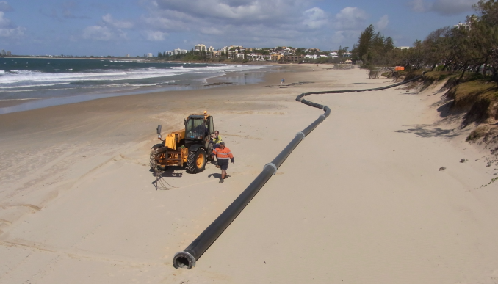*Figure 8. The pipeline delivering sand to eroded areas of Maroochydore Beach*

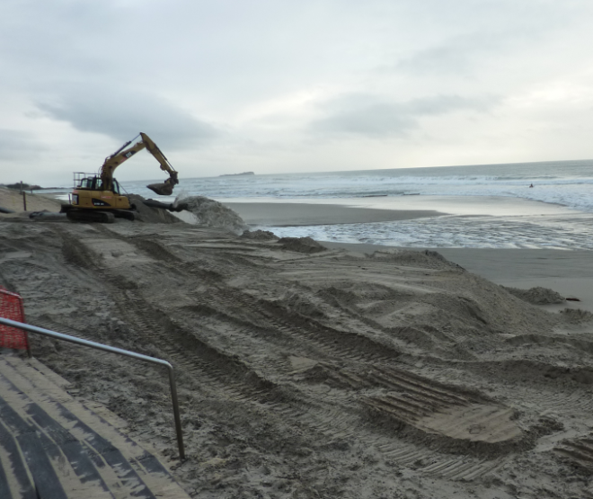*Figure 9. Machinery profiling sand on Maroochydore Beach.*

|  |
| --- |
| Further information |
| You can find further information about the project on Council’s website at [www.sunshinecoast.qld.gov.au](https://www.sunshinecoast.qld.gov.au/)  To contact Council’s project team please email coastalandcanals@sunshinecoast.qld.gov.au  Or we encourage you to contact Council’s customer service via the details below:  (07) 5475 7272  or [mail@sunshinecoast.qld.gov.au](mailto:mail@sunshinecoast.qld.gov.au)  And quote the project name. |

